Project 3 – Angry bird

F74047044 Chia Yoong Jia

Github username : krimson8

Below is the game made as required . However the shooting angle of the bird were set as 45` .

The basis of the program were acquired from the github provided in the PPT .

-There were 4 types of bird with different skill made with polymorphism and inherited from original Bird() class

-There was a label showing the scoring counter and speed counter .

-A restart button was made and fully functioning , along with a exit button

-Instruction of the game were also written in the game

-The physic effect used were from box2d library (windows)

-The enemy class and obstacle class were made according to the bird class

-Enemy will die when it reach certain speed

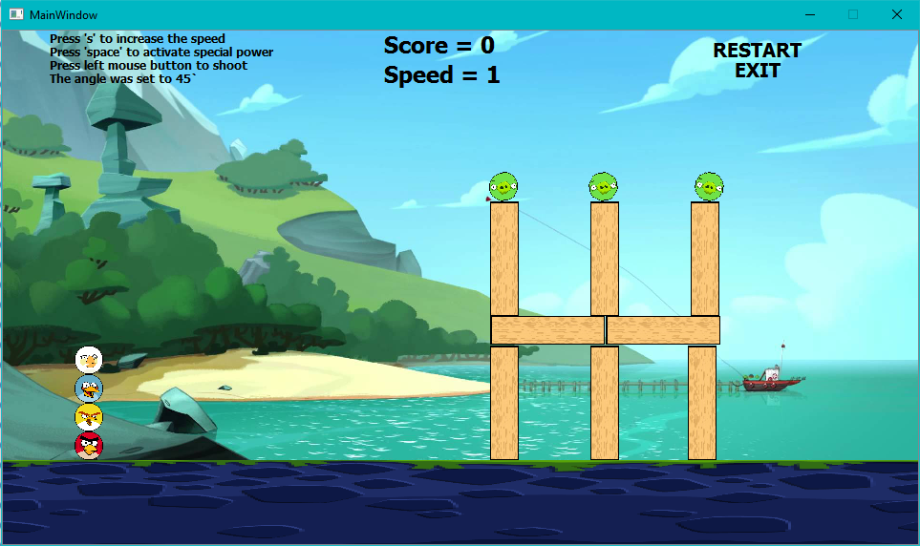

Press ‘s’ to increase the speed constant by 1

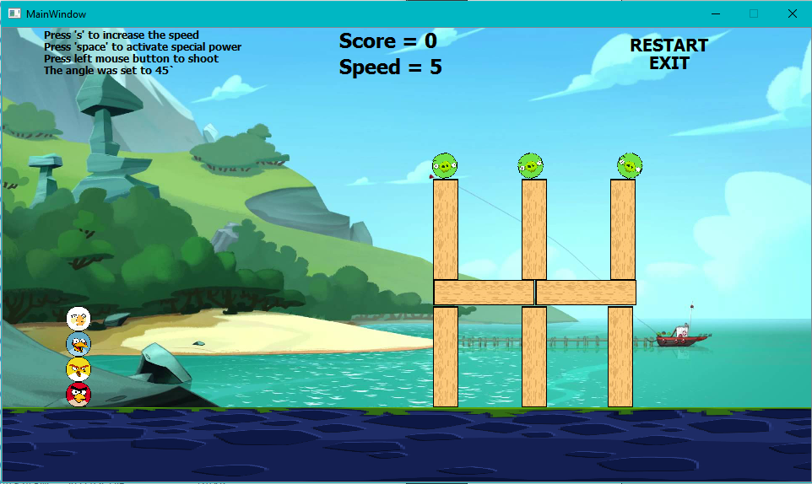

The physic effect were performing correctly , and the obstacle were stacking nice .

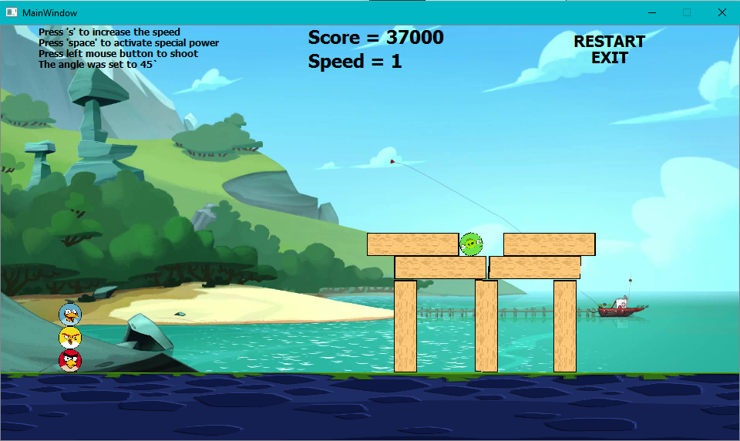

Additional gameplay screenshot :

